**Component Mapping**

**Create Database:**

* create database hibernate_mapping_component;

**Use database :**

* use hibernate_mapping_component;

**Prepare dynamic web app**

**Create dynamic webapp**

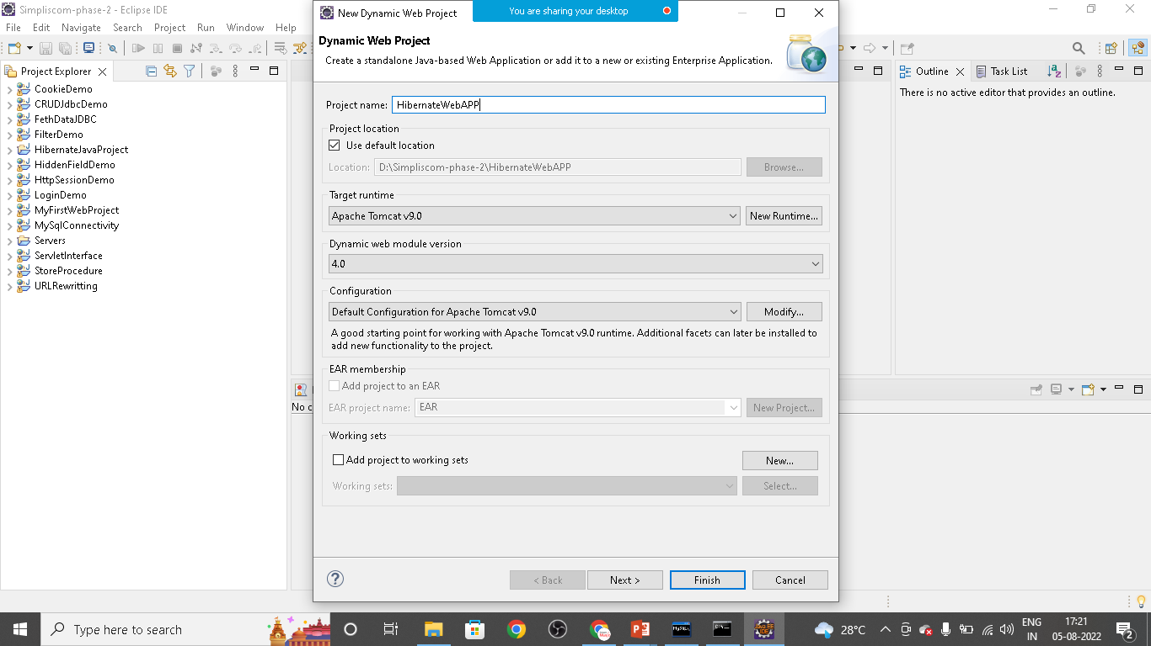

**Create** index.html **file**

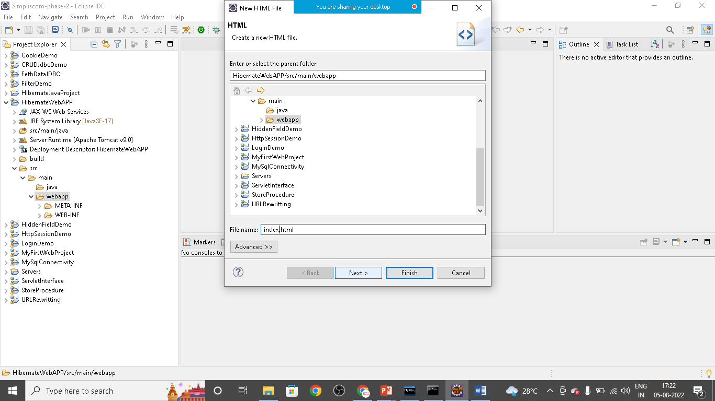

**Src>main>webapp>WEB-INF>lib>copy all hibernate jar file and mysql connector jar files**

Create **HibernateUtil** class

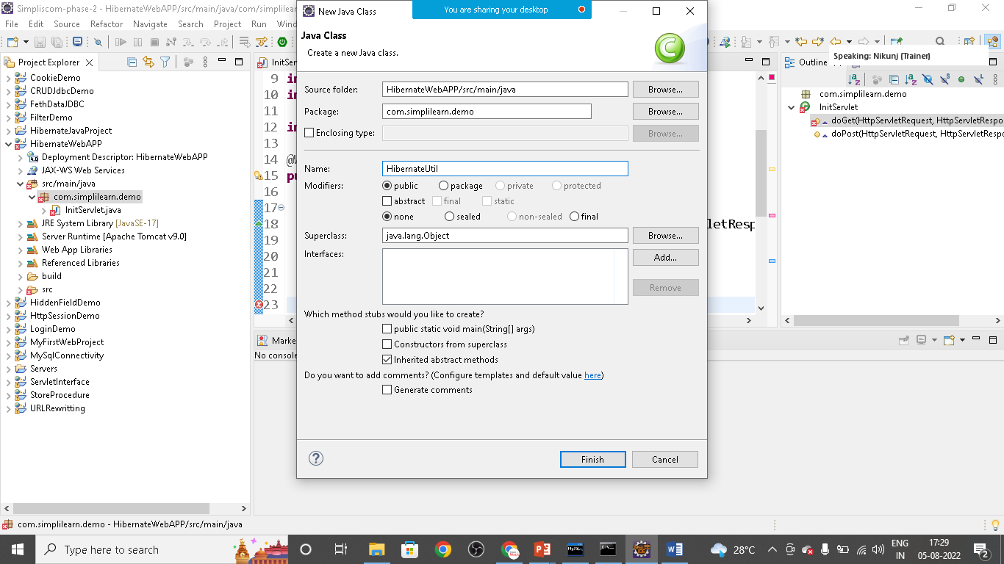

package com.simplilearn.demo;

import org.hibernate.SessionFactory;

import org.hibernate.boot.Metadata;

import org.hibernate.boot.MetadataSources;

import org.hibernate.boot.registry.StandardServiceRegistry;

import org.hibernate.boot.registry.StandardServiceRegistryBuilder;

public class HibenateUtil {

private static SessionFactory sessionFactory;

static {

try {

StandardServiceRegistry registry= new StandardServiceRegistryBuilder().

configure("hibernate.cfg.xml").build();

Metadata metadata= new MetadataSources(registry).getMetadataBuilder()

.build();

sessionFactory= metadata.getSessionFactoryBuilder().build();

}

catch(Exception e){

}

}

public static SessionFactory getSessionFactory() {

return sessionFactory;

}

}

Product

**package** com.simplilearn.demo;

**import** java.math.BigDecimal;

**public** **class** Product {

**private** **long** id;

**private** String name;

**private** BigDecimal price;

**private** ProductParts parts;

**public** Product() {

}

**public** Product( String name, BigDecimal price, ProductParts parts) {

**super**();

**this**.name = name;

**this**.price = price;

**this**.parts = parts;

}

**public** **long** getId() {

**return** id;

}

**public** **void** setId(**long** id) {

**this**.id = id;

}

**public** String getName() {

**return** name;

}

**public** **void** setName(String name) {

**this**.name = name;

}

**public** BigDecimal getPrice() {

**return** price;

}

**public** **void** setPrice(BigDecimal price) {

**this**.price = price;

}

**public** ProductParts getParts() {

**return** parts;

}

**public** **void** setParts(ProductParts parts) {

**this**.parts = parts;

}

}

ProductParts

**package** com.simplilearn.demo;

**public** **class** ProductParts {

**private** String hdd;

**private** String cpu;

**private** String ram;

**public** ProductParts() {

// **TODO** Auto-generated constructor stub

}

**public** ProductParts(String hdd, String cpu, String ram) {

**super**();

**this**.hdd = hdd;

**this**.cpu = cpu;

**this**.ram = ram;

}

**public** String getHdd() {

**return** hdd;

}

**public** **void** setHdd(String hdd) {

**this**.hdd = hdd;

}

**public** String getCpu() {

**return** cpu;

}

**public** **void** setCpu(String cpu) {

**this**.cpu = cpu;

}

**public** String getRam() {

**return** ram;

}

**public** **void** setRam(String ram) {

**this**.ram = ram;

}

@Override

**public** String toString() {

**return** "ProductParts [hdd=" + hdd + ", cpu=" + cpu + ", ram=" + ram + "]";

}

}

SaveDetailsServlet

**package** com.simplilearn.demo;

**import** java.io.IOException;

**import** java.io.PrintWriter;

**import** java.math.BigDecimal;

**import** javax.servlet.ServletException;

**import** javax.servlet.annotation.WebServlet;

**import** javax.servlet.http.HttpServlet;

**import** javax.servlet.http.HttpServletRequest;

**import** javax.servlet.http.HttpServletResponse;

**import** org.hibernate.Session;

**import** org.hibernate.SessionFactory;

**import** org.hibernate.Transaction;

@WebServlet("/save")

**public** **class** SaveDeatailServlet **extends** HttpServlet {

@Override

**protected** **void** doGet(HttpServletRequest req, HttpServletResponse resp) **throws** ServletException, IOException {

// **TODO** Auto-generated method stub

PrintWriter out=resp.getWriter();

String name=req.getParameter("pname");

String price=req.getParameter("pprice");

String hdd=req.getParameter("hdd");

String cpu=req.getParameter("cpu");

String ram=req.getParameter("ram");

ProductParts parts=**new** ProductParts(hdd,cpu,ram);

Product product=**new** Product(name,**new** BigDecimal(price),parts);

SessionFactory factory= HibernateUtil.*getSessionfactory*();

Session session= factory.openSession();

Transaction tx=session.beginTransaction();

session.save(product);

tx.commit();

session.close();

out.print("Data Added Successfully");

resp.sendRedirect("list");

}

@Override

**protected** **void** doPost(HttpServletRequest req, HttpServletResponse resp) **throws** ServletException, IOException {

// **TODO** Auto-generated method stub

doGet(req, resp);

}

}

**ListServlet**

**package** com.simplilearn.demo;

**import** java.io.IOException;

**import** java.io.PrintWriter;

**import** java.util.List;

**import** javax.servlet.ServletException;

**import** javax.servlet.annotation.WebServlet;

**import** javax.servlet.http.HttpServlet;

**import** javax.servlet.http.HttpServletRequest;

**import** javax.servlet.http.HttpServletResponse;

**import** org.hibernate.Session;

**import** org.hibernate.SessionFactory;

@WebServlet("/list")

**public** **class** ListServlet **extends** HttpServlet {

@Override

**protected** **void** doGet(HttpServletRequest req, HttpServletResponse resp) **throws** ServletException, IOException {

// **TODO** Auto-generated method stub

resp.setContentType("text/html");

SessionFactory factory= HibernateUtil.*getSessionfactory*();

Session session= factory.openSession();

List<Product> list=session.createQuery("from Product").list();

PrintWriter out=resp.getWriter();

out.print("<h1>Product List</h1>");

**for**(Product p:list) {

out.print("<b>"+p.getId()+". "+p.getName()+" "+p.getPrice()+"</b><br>");

ProductParts part=p.getParts();

out.print("HDD: "+part.getHdd()+"<br>");

out.print("CPU: "+part.getCpu()+"<br>");

out.print("RAM: "+part.getRam()+"<br>");

out.print("-------------------------------------<br>");

}

}

@Override

**protected** **void** doPost(HttpServletRequest req, HttpServletResponse resp) **throws** ServletException, IOException {

// **TODO** Auto-generated method stub

doGet(req, resp);

}

}

Create **resource** folder

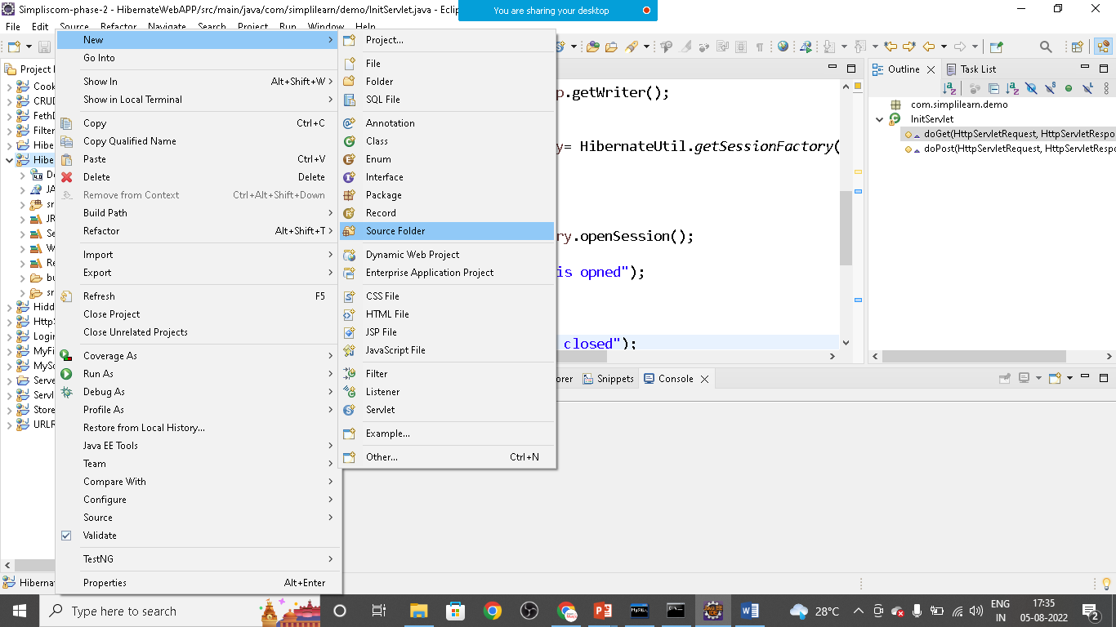

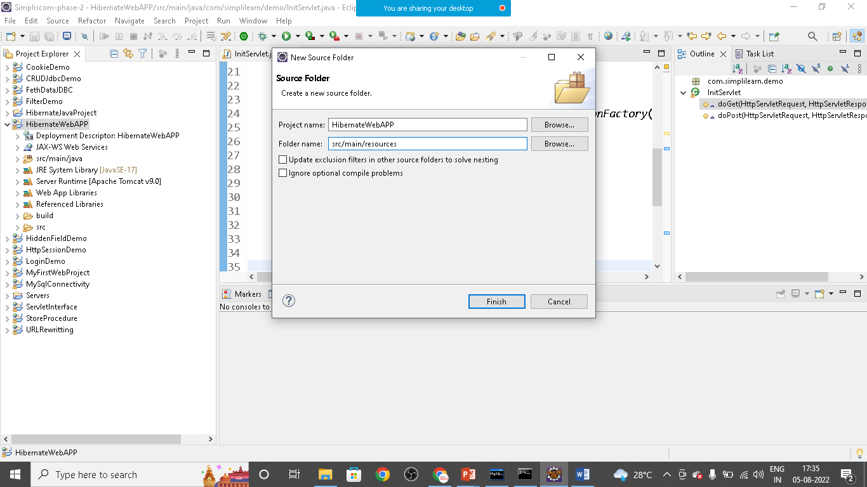

Create

1. hibernate.cgf.xml
2. product.hbm.xml

hibernate.cfg.xml

<?xml version=*"1.0"* encoding=*"UTF-8"*?>

<!DOCTYPE hibernate-configuration PUBLIC

"-//Hibernate/Hibernate Configuration DTD 3.0//EN"

"http://www.hibernate.org/dtd/hibernate-configuration-3.0.dtd">

<hibernate-configuration>

<session-factory>

<property name=*"connection.driver_class"*>com.mysql.cj.jdbc.Driver</property>

<property name=*"connection.url"*>jdbc:mysql://localhost:3306/hibernate_mapping_component</property>

<property name=*"connection.username"*>root</property>

<property name=*"connection.password"*>Nikunj@123</property>

<property name=*"hbm2ddl.auto"*>update</property>

<property name=*"dialect"*>org.hibernate.dialect.MySQL8Dialect</property>

<property name=*"show_sql"*>true</property>

<mapping resource=*"product.hbm.xml"*/>

</session-factory>

</hibernate-configuration>

product.hbm.xml

<?xml version=*"1.0"* encoding=*"UTF-8"*?>

<!DOCTYPE hibernate-mapping PUBLIC

"-//Hibernate/Hibernate Mapping DTD 3.0//EN"

"http://www.hibernate.org/dtd/hibernate-mapping-3.0.dtd">

<hibernate-mapping package=*"com.simplilearn.demo"* >

<class name=*"Product"* table=*"eproduct"* >

<id name=*"id"* type=*"long"* column=*"ID"*>

<generator class=*"increment"*></generator>

</id>

<property name=*"name"* type=*"string"*></property>

<property name=*"price"* type=*"big_decimal"*></property>

<component name=*"parts"* class=*"com.simplilearn.demo.ProductParts"*>

<property name=*"hdd"* column=*"parts_hdd"*></property>

<property name=*"cpu"* column=*"parts_cpu"*></property>

<property name=*"ram"* column=*"parts_ram"*></property>

</component>

</class>

</hibernate-mapping>

Index.html

<!DOCTYPE html>

<html>

<head>

<meta charset=*"ISO-8859-1"*>

<title>Insert title here</title>

</head>

<body>

<form action=*"save"* method=*"post"*>

Name:<input type=*"text"* name=*"pname"*><br><br>

Price:<input type=*"text"* name=*"pprice"*><br><br>

Hard Disc Details:<input type=*"text"* name=*"hdd"*><br><br>

CPU Details:<input type=*"text"* name=*"cpu"*><br><br>

RAM details:<input type=*"text"* name=*"ram"*><br><br>

<input type=*"submit"* value=*"Save Data Using Component"*><br><br>

</form>

<br>

<br>

<a href=*"list"*>Product Details</a>

</body>

</html>